Nama : Febrian Atmadhika

Universitas : Universitas Negeri Padang

* Halaman Home

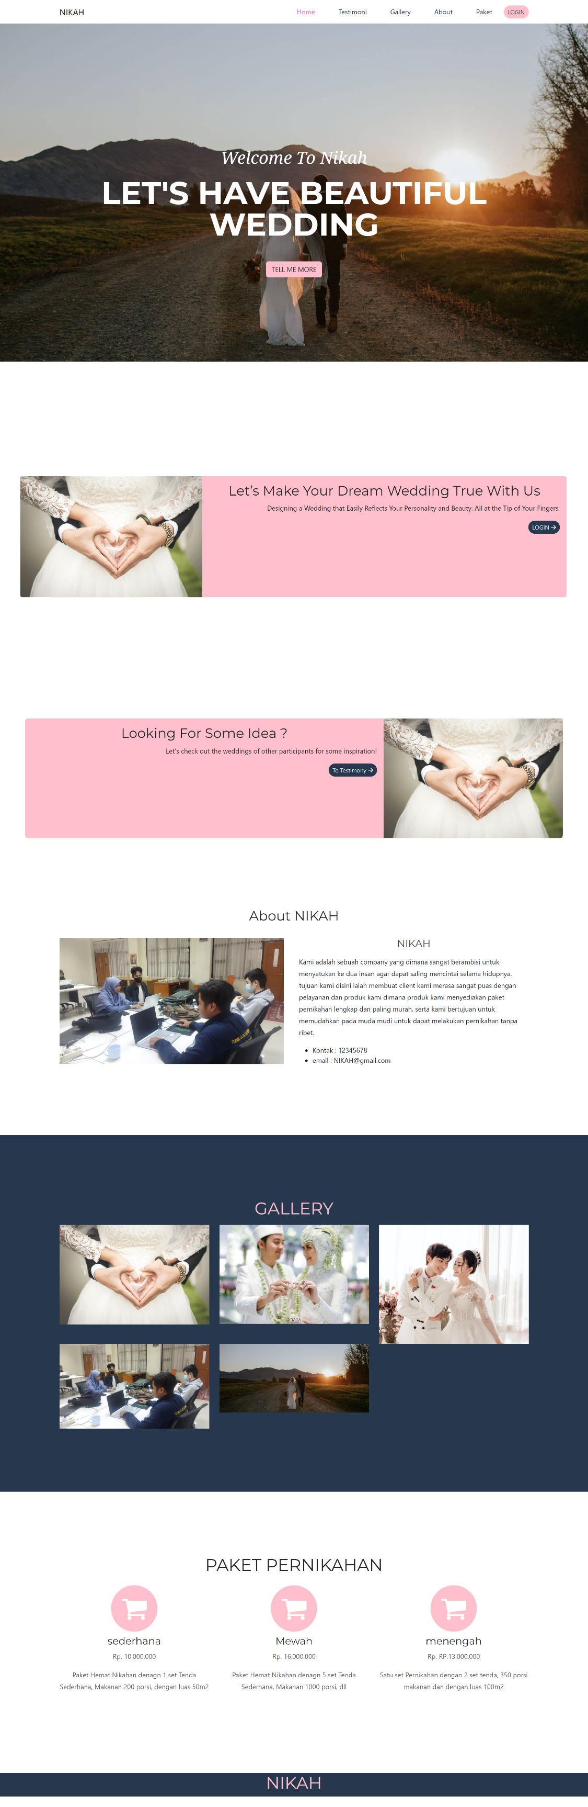

* Halaman Home



* Halaman Testimoni

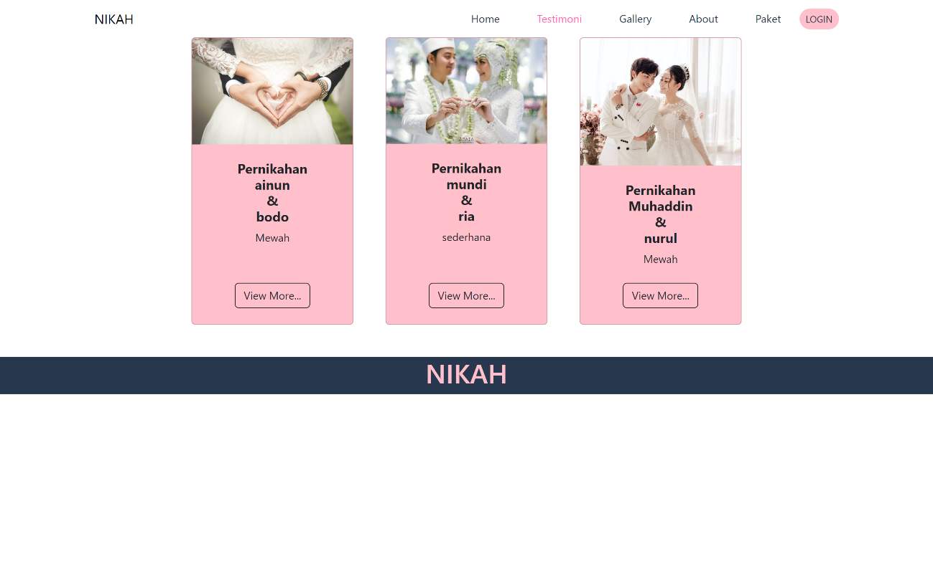

* Halaman Login

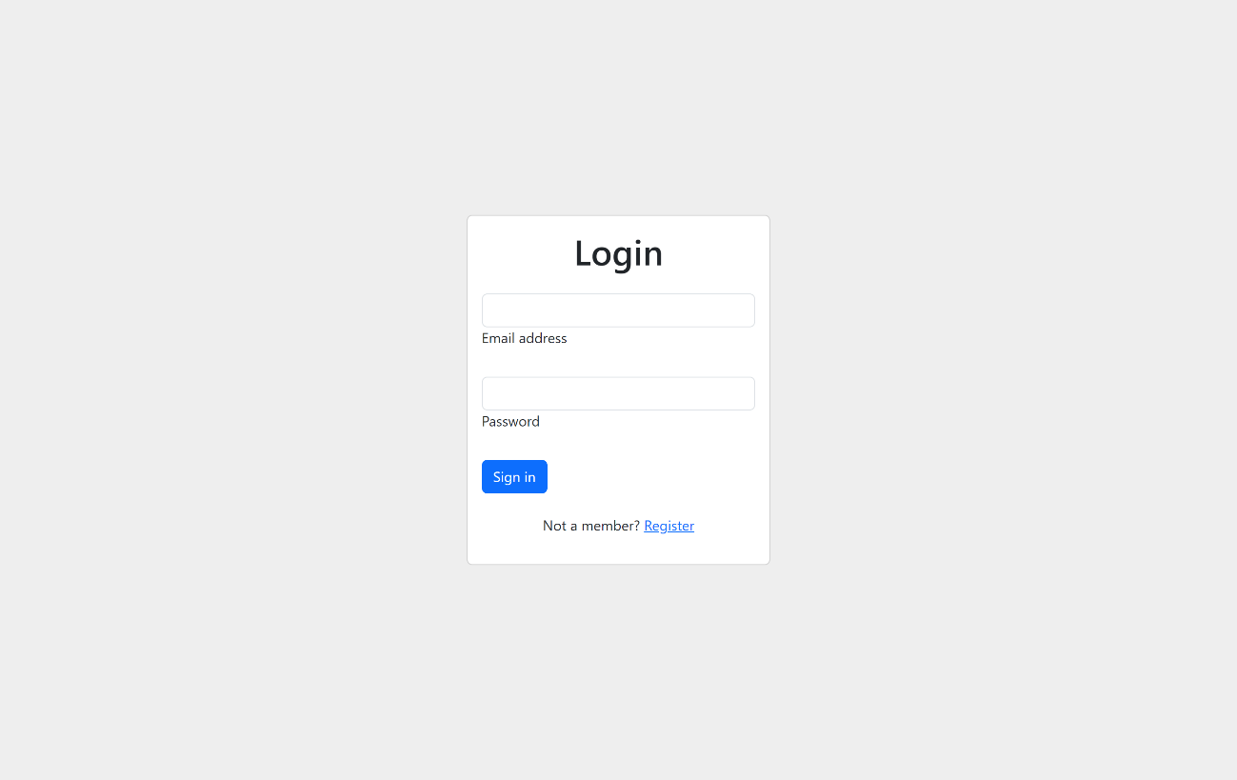

* Halaman Dashboard

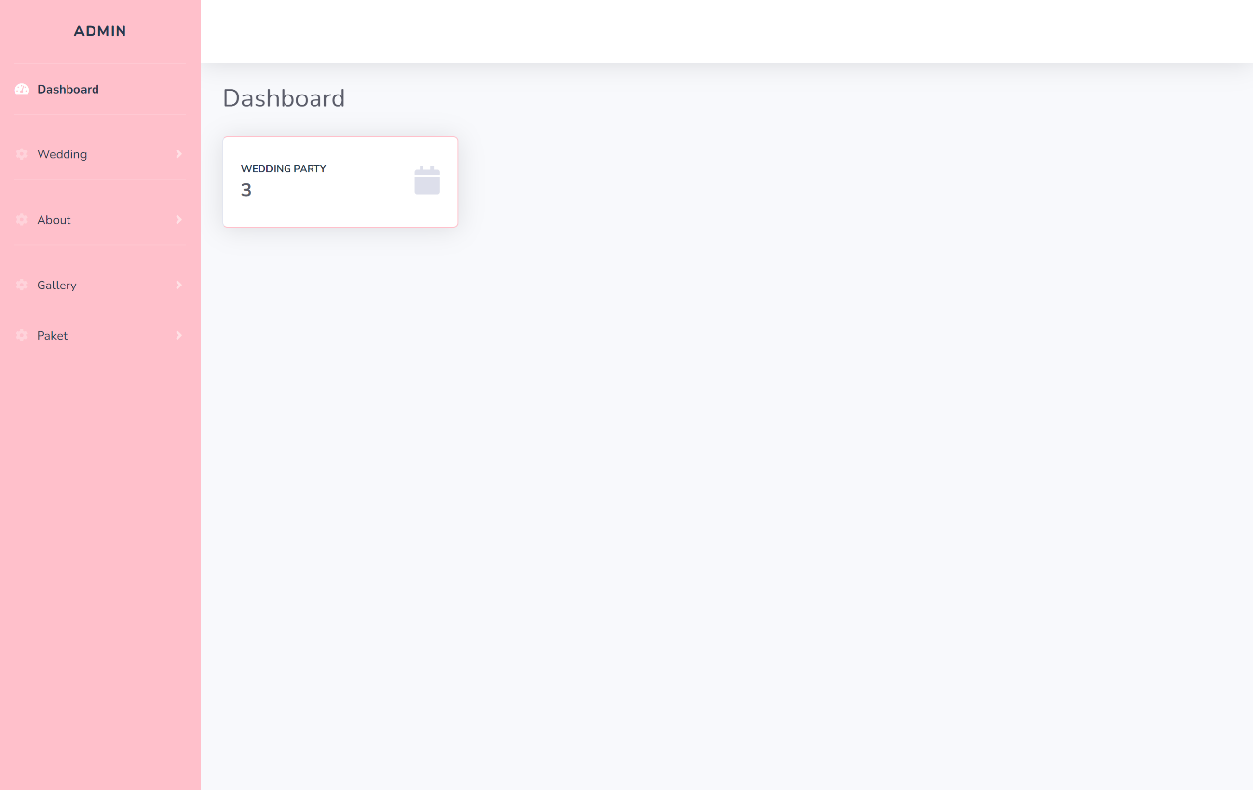

* Halaman List Wedding / Customer

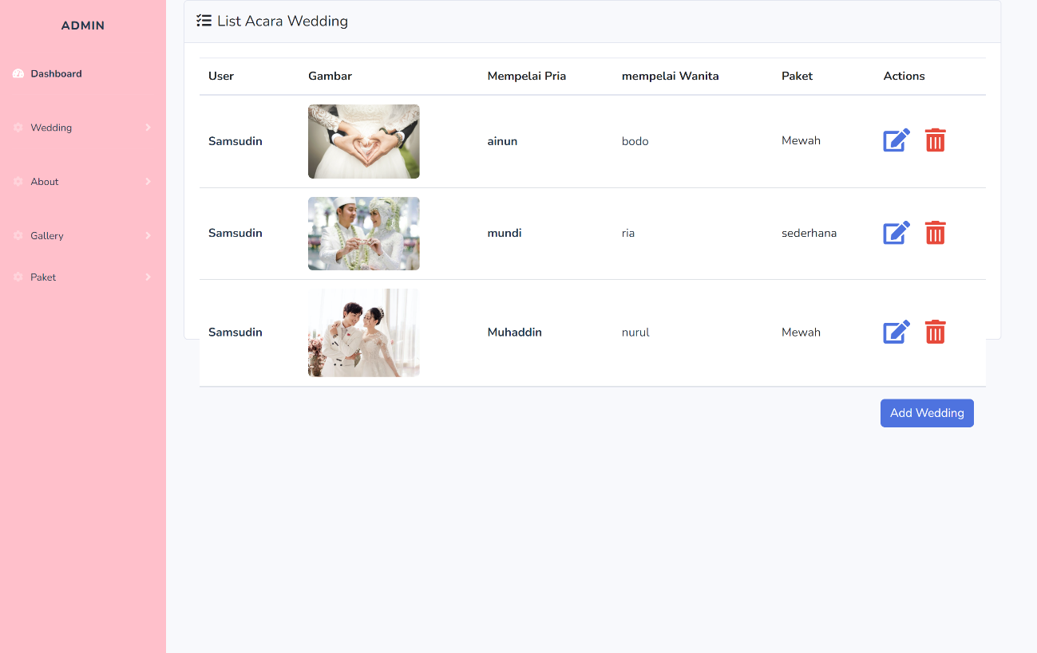

* Halaman List gallery

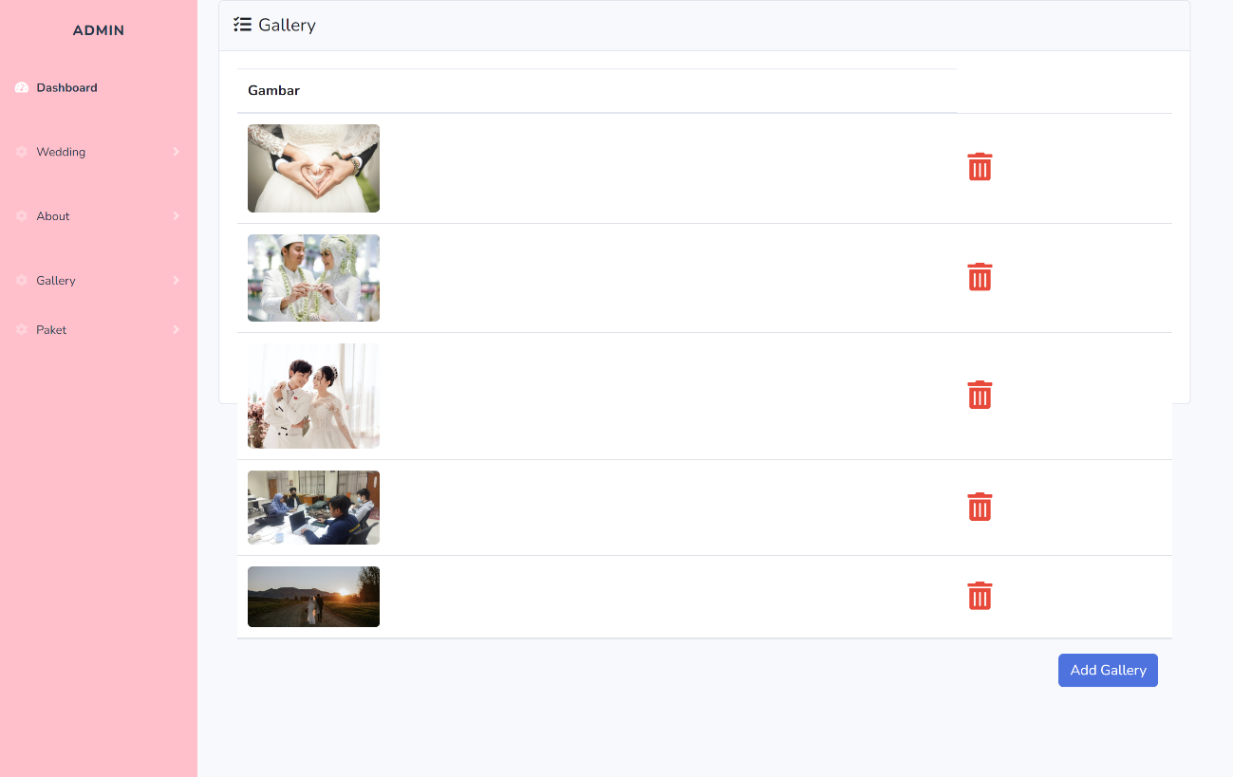

* Halaman List paket

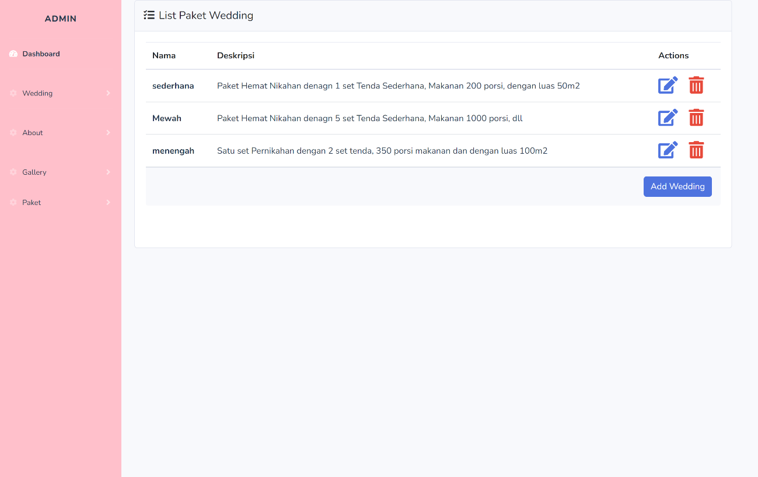

* Halaman Profile Company

